Alarm: ID 58: Flexi Double PH
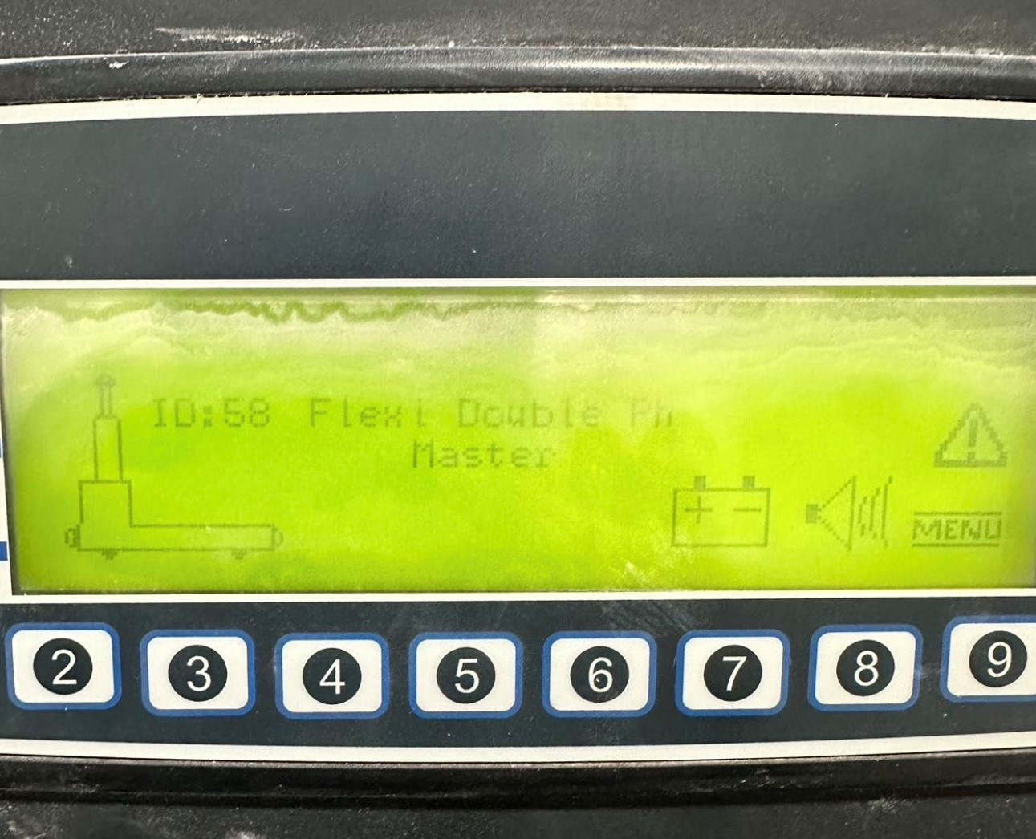
How To Fix:
This alarm is triggered by an issue with the front battery sensor.
To resolve:
- Ensure the sensor is lit up, with both lights visible on the wooden block or top of the battery.
- Perform the automatic sequence:
  - Automatic Mode
  - Press the Blue button
  - Press the Green button

